**BEEE ASSIGNMENT – II (UNIT 4)**

1. With the help of a neat diagram explain how BJT in Common Base (CB) configuration can be used as an amplifier?
2. Explain the following terms:
3. Thermal Runaway
4. Limits of Operation in BJT
5. Operating Point
6. Mathematically show how the operating point in an emitter stabilized bias circuit is independent of temperature.
7. Calculate the values of IE, IB and IC for the following circuit:

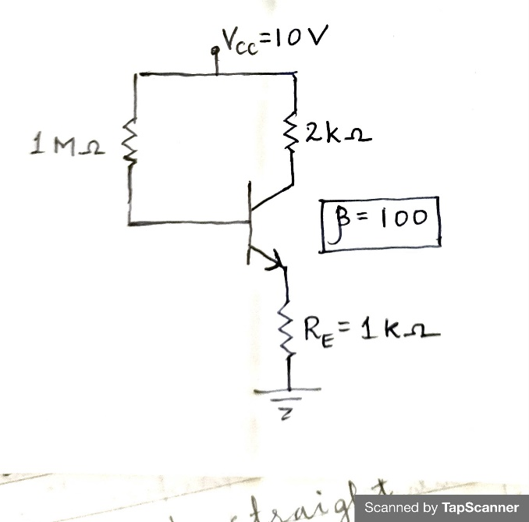

1. Find the coordinates of the operating point for the circuit shown below:

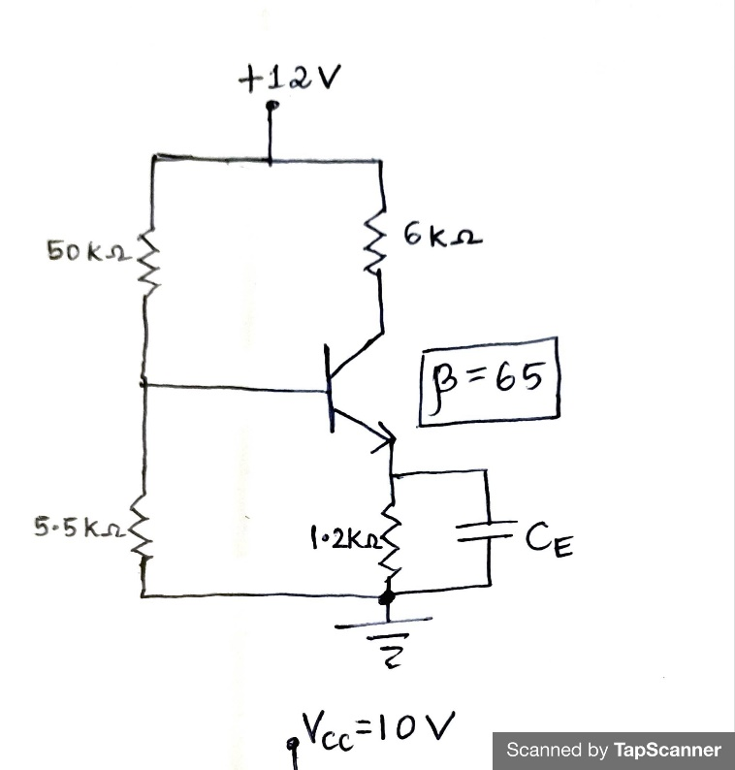

**Date of Submission: 24th January 2022**